**Task no1**

# 

***(Computer Networking Lab )***

**Muhammad Babar ALI**

*( SU92-BSSEM-F22-065 )*

BSSE – 5B ( 2022 – 2026)

**Department Of Software Engineering**

Submitted to: Sir Rasikh ali

Submitted on: Sep 21,2024

**Faculty Of CS&IT ( Gold Campus ), Superior University, Lahore**

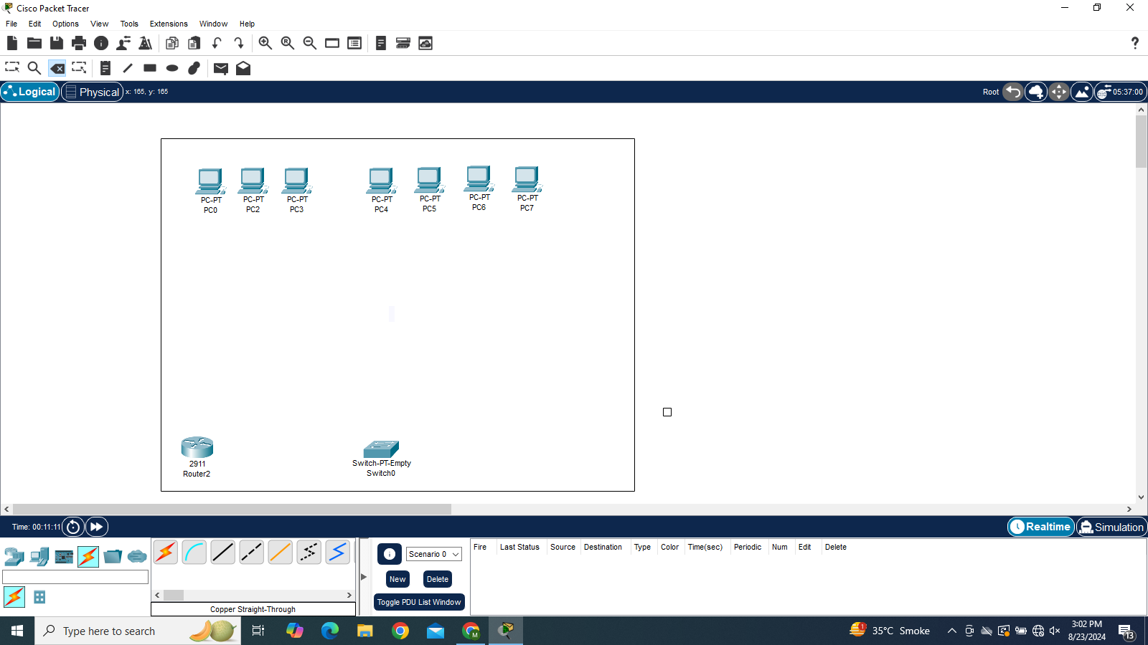

**Task 1;**

What is the difference between all the routers, and when to use them

(mentioned in cisco packet tracer)

In **Cisco Packet Tracer**, several types of routers are available for different networking scenarios. The main differences between them relate to their performance, features, and use cases. Here's an overview of the common types of routers you may encounter in Packet Tracer:

### 1. **Generic Routers (e.g., 1841, 1941, 2811, 2911, etc.)**

* **Purpose**: These are general-purpose routers commonly used in enterprise environments. They are part of Cisco’s Integrated Services Router (ISR) series.
* **Features**:
  + Support for a wide range of network protocols (e.g., IPv4, IPv6, routing protocols like OSPF, EIGRP).
  + Modular, allowing the addition of various network interface cards (NICs) to expand port capacity.
  + Suitable for WAN and LAN connections.
* **When to Use**:
  + In small to medium-sized networks for routing between LAN segments and connecting to external networks (WAN).
  + For labs where basic routing protocols and configurations need to be tested.

**Examples**:

* **Cisco 1841**: An older model, suitable for simple networks with limited port options.
* **Cisco 1941**: Newer than 1841, supports more protocols and features.
* **Cisco 2811** and **2911**: Part of the ISR G2 series with better performance and support for advanced services like security, VoIP, and more complex routing.

### 2. **High-Performance Routers (e.g., 7200, 4300 Series)**

* **Purpose**: These routers are designed for high-throughput networks where performance is critical.
* **Features**:
  + High-speed routing for large-scale networks.
  + Support for high bandwidth and advanced features like MPLS, VPNs, and advanced QoS.
  + Large memory and processing power for handling extensive routing tables and high traffic volumes.
* **When to Use**:
  + In large enterprise networks or service provider environments.
  + For scenarios that involve complex and high-speed routing, such as backbone routing or connecting large branches.

**Examples**:

* **Cisco 7200**: High-performance router used in service provider networks or large-scale enterprise networks.
* **Cisco 4331/4351**: From the ISR 4000 series, designed for modern, high-throughput environments with high performance and support for advanced services.

### 3. **Home Routers (e.g., 819, 829)**

* **Purpose**: Designed for small/home office (SOHO) or mobile networks.
* **Features**:
  + Support basic routing features for small networks.
  + Usually limited in terms of port capacity and scalability.
  + Often include wireless interfaces for mobile connectivity (4G/5G).
* **When to Use**:
  + In simulations of small branch office setups or home networks where basic routing is needed.
  + When configuring mobile network routers or wireless routers.

**Examples**:

* **Cisco 819**: A compact router for SOHO or mobile environments, supports cellular connectivity.
* **Cisco 829**: Advanced version of 819 with more robust features.

### 4. **Wireless Routers**

* **Purpose**: These routers provide both wired and wireless networking capabilities.
* **Features**:
  + Support for WLAN protocols (e.g., 802.11a/b/g/n/ac).
  + Acts as both a router and a wireless access point.
  + Often includes built-in security features like firewalls.
* **When to Use**:
  + For scenarios that involve wireless networking alongside traditional wired routing.
  + In smaller networks where wireless coverage is necessary (e.g., SOHO).

**Examples**:

* Wireless routers like **Cisco WRT** are typically used for basic wireless connectivity in homes and small offices.

### 5. **Multi-Services Routers**

* **Purpose**: These routers provide additional services beyond basic routing, such as voice, video, and security services.
* **Features**:
  + Support for voice (VoIP), security (VPNs, firewalls), and more.
  + Integration of multiple services in a single device.
* **When to Use**:
  + In networks where integrated services like voice and security are required, such as unified communications.

**Examples**:

* The **ISR G2** series (1941, 2911, etc.) can be classified as multi-service routers due to their wide range of capabilities.

**Task 2;**

What is the difference between all the switches, and when to use them

(mentioned in cisco packet tracer)

In **Cisco Packet Tracer**, several types of switches are available, each designed for different networking environments and use cases. The main differences between them relate to their capabilities, performance, and features. Here's a breakdown of the various types of switches commonly found in Packet Tracer and when to use them:

### 1. **Unmanaged Switches (e.g., 2960)**

* **Purpose**: These switches provide basic Layer 2 functionality with no advanced features or configuration required.
* **Features**:
  + Plug-and-play operation with no configuration required.
  + Basic Ethernet connectivity, switching, and MAC address table management.
  + No VLANs, quality of service (QoS), or security features.
* **When to Use**:
  + In small networks where simple connectivity is required, such as basic office or home network setups.
  + In scenarios where advanced management features are not necessary.

**Examples**:

* **Cisco 2960**: A common Layer 2 switch that provides basic port connectivity and switching without advanced configuration options.

### 2. **Managed Layer 2 Switches (e.g., 2960, 2960-24TT)**

* **Purpose**: These switches are designed to operate primarily at Layer 2 (Data Link Layer) but with some management and configuration capabilities.
* **Features**:
  + Support for Virtual LANs (VLANs), trunking, and basic security features (e.g., port security).
  + Can handle Spanning Tree Protocol (STP) to prevent network loops.
  + No routing capabilities (Layer 2 only), but can manage inter-VLAN communication through a separate router.
* **When to Use**:
  + In small to medium-sized enterprise networks where VLAN segmentation is required.
  + For basic managed network environments where control over traffic flow is necessary.

**Examples**:

* **Cisco 2960**: In its managed version, it supports VLANs, STP, and basic security features, making it a good choice for small and medium-sized networks.

### 3. **Layer 3 Switches (e.g., 3560, 3650)**

* **Purpose**: These switches provide routing capabilities in addition to Layer 2 switching, allowing them to handle both routing and switching in a single device.
* **Features**:
  + Can perform routing between VLANs (inter-VLAN routing) without the need for a dedicated router.
  + Support for advanced Layer 3 protocols like OSPF, EIGRP, RIP, and static routing.
  + VLAN support, QoS, access control lists (ACLs), and advanced security features.
* **When to Use**:
  + In medium to large enterprise networks where routing between VLANs is needed.
  + For distribution or access layer roles in campus networks that require both routing and switching.
  + In scenarios where reducing the need for dedicated routers by incorporating routing into switches can simplify network design.

**Examples**:

* **Cisco 3560**: A Layer 3 switch that supports inter-VLAN routing and routing protocols.
* **Cisco 3650**: A more advanced version, often used in more demanding environments with higher performance needs.

### 4. **Multilayer Switches (e.g., 3850, 9300)**

* **Purpose**: These switches are designed for both high-performance Layer 2 and Layer 3 operations, often used in the core or distribution layer of enterprise networks.
* **Features**:
  + High throughput for large networks, combining routing and switching features.
  + Support for advanced Layer 3 routing protocols (OSPF, EIGRP, BGP) and Layer 2 protocols (VLANs, STP).
  + Enhanced security, redundancy, and availability features, often with support for stacking and modular expansion.
  + QoS, ACLs, and advanced security capabilities to handle more complex traffic requirements.
* **When to Use**:
  + In large enterprise networks where high performance and scalability are crucial.
  + For core or distribution layers of the network where both high-speed switching and routing are needed.
  + In high-availability environments where redundant and scalable designs are necessary.

**Examples**:

* **Cisco 3850**: A powerful, enterprise-grade switch that can handle large volumes of traffic with Layer 3 routing.
* **Cisco 9300**: Part of the Catalyst 9000 series, designed for advanced enterprise applications with a focus on security, performance, and scalability.

**Task 3;**

What is the difference between all the connection wires, and when to use them

(mentioned in cisco packet tracer)

In **Cisco Packet Tracer**, various types of connection wires (cables) are used to simulate different types of network connections. Here's a breakdown of the common connection types and when to use them:

### 1. **Console Cable (Light Blue)**

* **Use:** This is used to connect to the **console port** of a network device (e.g., a router or switch) for **initial configuration** or management purposes.
* **When:** When you need to configure a device that does not have an IP address yet or is inaccessible over the network.
* **Connector Type:** RJ-45 to RS-232.

### 2. **Copper Straight-Through Cable (Black)**

* **Use:** A standard Ethernet cable used to connect devices of **different types**.
* **When:**
  + PC to a switch.
  + Router to a switch.
  + PC to a router (using FastEthernet interfaces).
* **Connector Type:** RJ-45.

### 3. **Copper Crossover Cable (Red)**

* **Use:** An Ethernet cable used to connect devices of the **same type** directly, such as PC-to-PC, switch-to-switch, or router-to-router (without using a hub or switch).
* **When:** Typically used when directly connecting two similar devices.
* **Connector Type:** RJ-45.

### 4. **Fiber Optic Cable (Yellow)**

* **Use:** This cable is used for long-distance, high-speed connections between network devices, such as routers or switches, that support **fiber-optic connections**.
* **When:** Used in environments where high bandwidth and long-distance connections are required.
* **Connector Type:** LC or SC connectors depending on the device.

### 5. **Serial Cable (Light Purple)**

* **Use:** Serial cables are used to connect **WAN** (Wide Area Network) interfaces between routers for long-distance communication.
* **When:** When connecting routers using serial interfaces to simulate WAN links.
* **Connector Type:** DB-60 or Smart Serial.

### 6. **Coaxial Cable (Not commonly seen in Packet Tracer)**

* **Use:** Coaxial cables are often used in **legacy networks** or to connect devices in a **cable TV network** (Cable internet, DOCSIS).
* **When:** Typically used in older or specific cable network scenarios.
* **Connector Type:** BNC or F-type.

### 7. **Phone Cable (Purple)**

* **Use:** Simulates a phone line connection used in older analog or digital **voice networks**.
* **When:** Used to connect modems or simulate a dial-up connection or VoIP scenarios in older network setups.
* **Connector Type:** RJ-11.

### 8. **Copper Straight-Through with DSL Modem (Gray)**

* **Use:** Connects a PC or network device to a DSL modem for internet connections.
* **When:** Used when simulating broadband (DSL) internet access.
* **Connector Type:** RJ-45.

### 9. **Automatic (Yellow Lightning Icon)**

* **Use:** This feature automatically selects the appropriate cable type based on the connected devices.
* **When:** Useful when you're unsure of the correct cable type or want a quick setup without manually selecting cables.